Install mongo and some searching conditions

(when switching location, need to add new ip to mongo)

Can manipulating date in the mongocompass or mongoshell

1.download

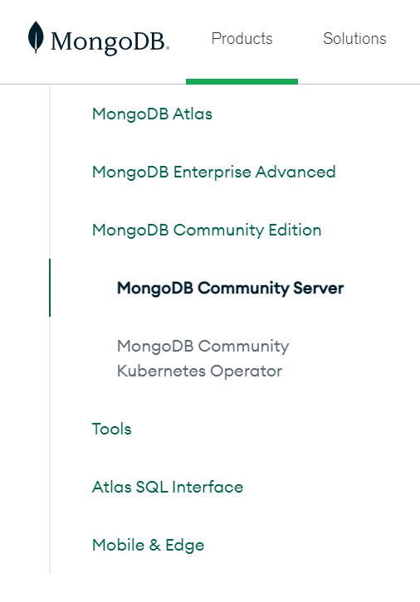

Version, os, package: msi

Add bin 4.0 or 6.0 to the system variable environment => can access to the mongo anywhere, don’t need to access to the bin folder anymore

2.starting server

Change directory to the bin folder

Run file mongod.exe

3.creating local database

In the video using cmd, but I don’t know way to install mongo. Specifically, it have error don’t recognize mongo,

So I use mongodb compass, it use mongo sh, it the same with cmd version

Create local db: use dbname

4. Insert to the db

Db.tours.insertMany([{name: “”, description: “”}])

5. Search all item

Db.tours.find()

6. Searching in specific item or search by property (key, value pairs)

Db.tours.find({difficulty: “easy”})

Searching for specific item but with condition operator



$lte specify: less than or equal

$lt: less than

Searching with more than 1 condition – other name: and operator



Test by myselft – or operator: 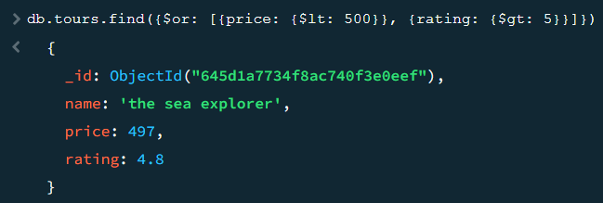

Searching item with single property only

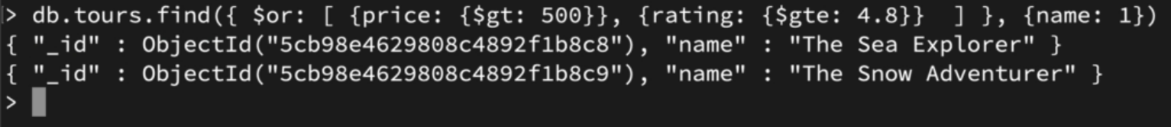

7.updating document

Using $set operator

First: specify the item we want to update, Second: set property we want to update



Updating by inserting a property to each item



8.delete item

Delete one:

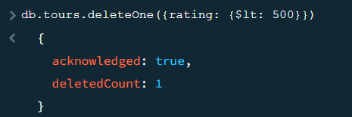

Delete many:

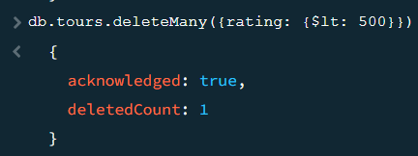

Finally check again on the mongo collections at mongodb atlas

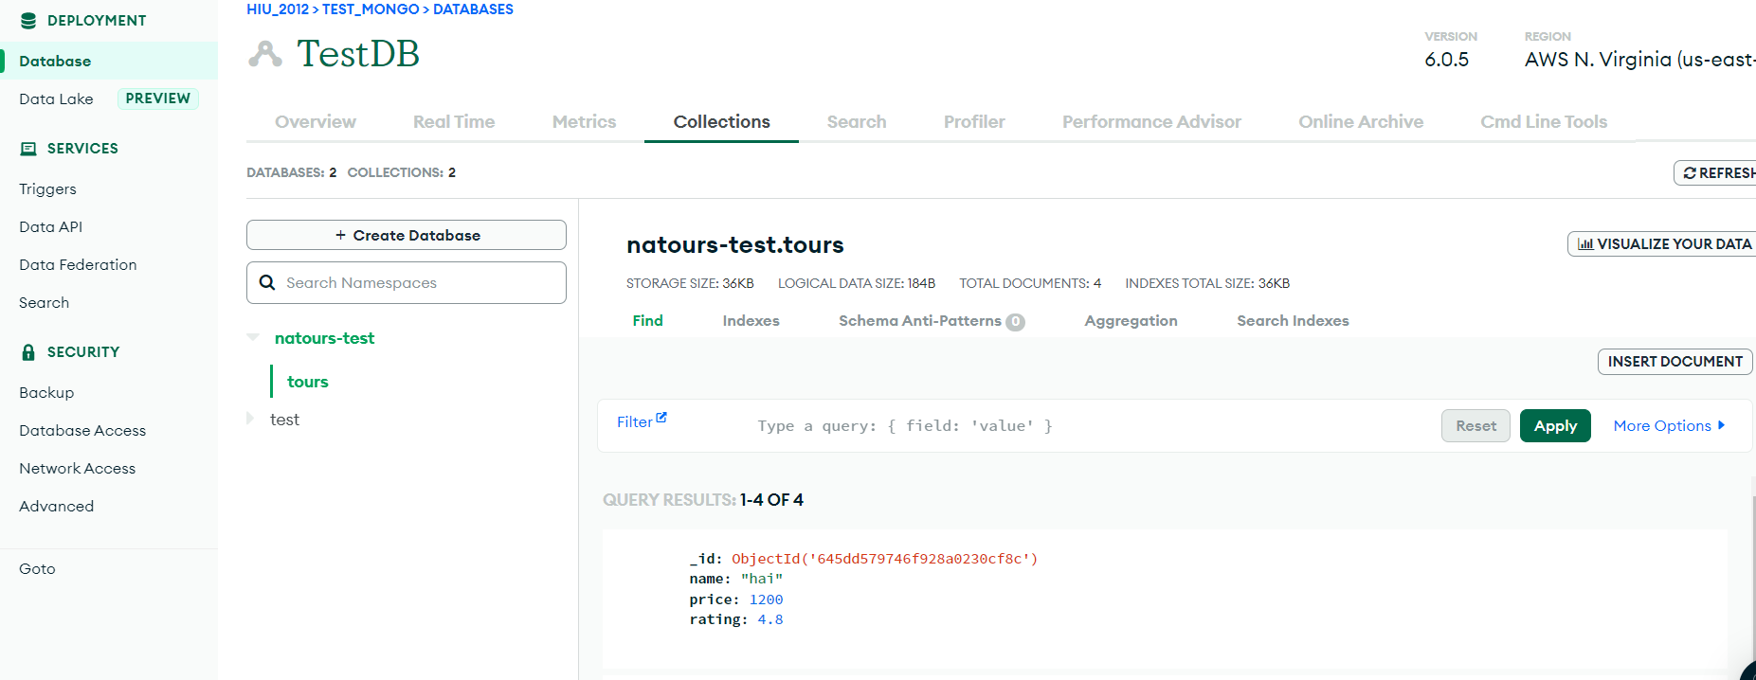

If want to access from anywhere

